Study Title :
A Phase II Randomized Double-Blind Study to Evaluate the Safety and Efficacy of Drug XYZ in Patients with Type 2 Diabetes Mellitus.
Study Overview:
This mock clinical trial is designed to evaluate the safety and efficacy of Drug XYZ in adult patients diagnosed with Type 2 Diabetes Mellitus. The study compares Drug XYZ against placebo over a 12-week treatment period.

Clinical Study Parameters
Parameter | Detail
Study ID | T2DM-001
Phase | II
Study Type | Randomized
Blinding | Double Blind
Arms | Drug XYZ vs Placebo
Sample Size | 100
Duration | 12 Weeks
Indication | Type 2 Diabetes
Primary Endpoint | HbA1c Reduction

Inclusion Criteria :

• Male or female subjects aged 18–65 years
• Diagnosed with Type 2 Diabetes Mellitus
• HbA1c between 7% and 10%
• Able to provide informed consent

Exclusion Criteria :

• Pregnant or lactating women
• Severe renal impairment
• Active malignancy
• History of cardiovascular event within 6 months

Visit Schedule :

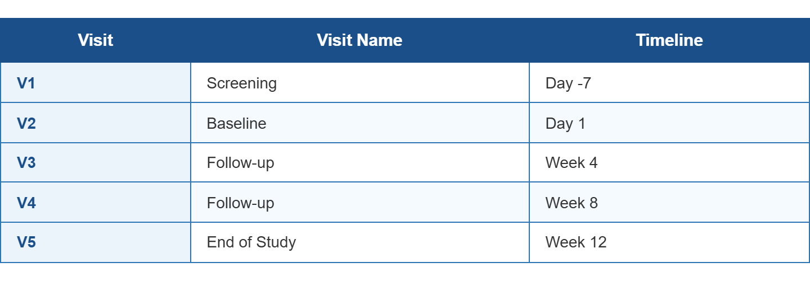

Data to be Collected:

The following data will be collected during the study:
• Demographics
• Medical History
• Vital Signs
• Laboratory Results
• Adverse Events
• Concomitant Medications
Safety Monitoring:

All adverse events occurring during the study period will be documented and assessed for severity, seriousness, and relationship to study medication.

Study Conclusion:

This project simulates an electronic data capture workflow used in modern clinical trials and demonstrates understanding of clinical data management principles.

